**TRADING SYSTEM (TREDOS)**

(Web Application Project)

Submitted in partial fulfillment of the requirement for the degree of Bachelor of computer engineering awarded by Pokhara University.

**SUBMITTED BY:**

Milan Tarami (15070317) Kiran Kandel (15070310)

Man Bahadur Khamcha (15070314) Birendra Ranabhat (15070302)

Manuk Thapa Magar (15070316) Milan Thapa (15070318)

Laxmi KC (15070312) Parvati Sharma (15070319)

Bishnu Aryal (15070303) Astitwa KC (15070299)



**Lumbini Engineering, Management & Science College**

Bhalwari, Rupandehi

Janaury, 2018

**Recommendation**

This is to certify that this project entitled “Trading System (Tredos)” prepared and submitted by Milan Tarami*,* Kiran Kandel*,* Man Bahadur Khamcha*,* Manuk Thapa Magar*,* Birendra Ranabhat *,* Milan Thapa*,* Astitwa KC*,* Bishnu Aryal*,* Laxmi KC andParvati Sharma in partial fulfillment of the requirements of the Degree of Bachelor in Computer Engineering awarded by Pokhara University, has been completed under my supervision. Thus I would like to recommend this project for final presentation as well as acceptance by the University.

………………………………… …………………………………..

Supervisor Date Signed

**Certificate**

This project entitled “Trading System (Tredos)”, prepared and submitted by Milan Tarami*,* Kiran Kandel*,* Man Bahadur Khamcha*,* Manuk Thapa Magar*,* Birendra Ranabhat,Milan Thapa*,* Astitwa KC*,* Bishnu Aryal*,* Laxmi KC andParvati Sharma has been examined by us and is accepted for the award of degree on Bachelor in Computer Engineering by Pokhara University

…………………………………………. ………………………………………

External Examiner Supervisor

…………………………………………. …………………………………………

Head of Department Principal

Date Signed: ……………………………

**Declaration**

We hereby declare that this project entitled “Trading System (Tredos)”, is based on our original research work, where it is indebted to the work others, acknowledgements has duly been made.

1. Milan Tarami (15070317) ………………………….....
2. Kiran Kandel (15070310) …………………………….
3. Man Bahadur Khamcha (15070314) ……………………............
4. Manuk Thapa Magar (15070316) ….………………………….
5. Birendra Ranabhat (15070302) …………………………….
6. Milan Thapa (15070318) ..………………………….
7. Laxmi KC (15070312) …………………………….
8. Parvati Sharma (15070319) ……………………………….
9. Bishnu Aryal (15070303) …...………………………….
10. Astitwa KC (15070299) ...…………………………….

Date signed: …………………………………….

**Acknowledgement**

We express our sincere thanks to our Project supervisor Mr. Satish Kumar Karna for his continuous support during the entire project development activities. The successful completion was only possible with his technical as well as academic support.

We extend our gratitude to Dr. K. N. Pandey, Member Secretary and Er. Lekhnath Pandey, Principal of Lumbini Engineering, Management and Science College, for his valuable support and inspiration to do this project.

1. Milan Tarami (15070317)
2. Kiran Kandel (15070310)
3. Man Bahadur Khamcha (15070314)
4. Manuk Thapa Magar (15070316)
5. Birendra Ranabhat (15070302)
6. Milan Thapa (15070318)
7. Laxmi KC (15070312)
8. Parvati Sharma (15070319)
9. Bishnu Aryal (15070303)
10. Astitwa KC (15070299)

**Abstract**

A case study about a Web Application that is entitled as a “Trading System (Tredos)” was a quite challenging task for us. The main objective of this project is to provide an online web application which will help easier way for record maintenance in a store and to remove an old system i.e. keeping a records in a written documents. Keeping a records in a written documents is tedious process and the written documents need to be cared much because it might be torn and accurate records couldn’t be maintained. But with the help to this project this record maintenance will be easier and faster.

From our study we have found that most of the management works for products are done in a written documents and they are getting a problem that accurate record is not maintained. But after preparing this project this problem will be reduced and more features will be added such as real time tracking available stock items (products) , keeping a customer’s information, keeping order information, etc.

**TABLE OF CONTENTS**

**Contents Page no.**

**SECTION-A INTRODUCTION**

1. Introduction 2
2. Statement of problem 3
3. Project scope 4
4. Objectives 5

**SECTION-B BACKGROUND COVERAGE**

1. Atom Text Editor 7
   1. Introduction 7
2. PHP 7
3. MySQL 8
4. HTML and CSS 8
5. JavaScript 8-9
6. JQuery 9
7. AJAX 9

**SECTION-C PLANNING THE PROJECT**

1. Overview 11
2. Realizing the problem 11-12
3. Planning the development process 12-14
   1. The phase life cycle model 13
   2. Work breakdown structure 14
4. Planning an organization structure 15
   1. Project structure 15
5. Cost analysis 15
6. Tools and software to be used 16
7. Language and framework 16

**SECTION-D ANALYSIS AND DESIGN**

1. Analysis 18
   1. User analysis 18
   2. Web Application analysis 18
2. Requirements gathering 18-19
3. Design 20-22
   1. Design overview 20
   2. Design activities 20-22
4. Data Flow Diagram 22-23

**SECTION-E DESIGN AND IMPLEMENTATION**

1. Testing 29-31
   1. Introduction 29
   2. Testing Process 29-31
2. Implementation 31-32

**SECTION-F LIMITATIONS AND FUTURE ENHANCEMENTS**

1. Limitations 34
2. Conclusion 34
3. Future Enhancements 34

**LIST OF TABLES**

**Name of Table Page no.**

1. Cost analysis 15

**LIST OF FIGURES**

**Name of figure Page no.**

1. The phase life cycle 13
2. Work Breakdown Structure 14
3. Design Pyramid of Web App 20
4. 0 – Level Data Flow Diagram 22
5. 1 – Level Data Flow Diagram 23
6. Admin Login Page 24
7. Admin Dashboard Page 24
8. Trading Member Management Page 25
9. News and Event Management Page 25
10. User Dashboard 26
11. Status Checker 26
12. Index Page 27

**SECTION-A**

**INTRODUCTION**

**INTRODUCTION**

Trade is simply the transfer of goods or services from one entity to another which may be an international trade, national trade or local trade (e.g. trade between wholesaler and retailer). During trade there is a danger of frauds which is increasing day by day. Our main concern is on the fraud involved in local trade.

Fraud detection is a critical issue for wholesaler determined to prevent loss and customer trust. The most prominent recent fraud involved in the context of our country in trade sector is payment delay and changing wholesalers by the retailer without clearing the previous credit. Retailer at first take some goods in cash and later borrow the items. Some retailers pay the credit in time while some of them change the wholesalers without clearing the credit amount. This has become a critical issue and till now no any significant efforts have been made in our country to stop these frauds. On this era of information and technology, people expect everything faster, easier and secure. Every day, the desire of people is increasing exponentially. Accessing every possible means and resources, news, notice, information, etc. via computers or smartphones has become a global demand. Everyone expect their work to be carried out in an easier and reliable way in few seconds sitting in front of computer. So, our main aim is to develop a digitally operated system that easily helps to recognize those frauds and help the wholesalers. Trading system not only targets on stopping these fraud activities but also providing useful information towholesalers as well as retailers about the recent changes in the trade market.

**STATEMENT OF PROBLEM**

1. **Lack of fraud analysis:** No any significant efforts have been made by government sector or any private sector to detect the frauds and punish them.
2. **Lack of proper information flow:** Any information or noticespublished by concerned authority does not seems to be delivered to the wholesalers and retailer at the same time. This may result in delay of information flow which may create unpleasant situations.
3. **Lack of digital solutions of common queries:** Many queries maybe common among the traders. Instead of visiting the concerned authority for general queries, it will be appropriate to go for a digital way for solving it at the real time.

**PROJECT SCOPES**

This project “Trading System (Tredos)”, is intended to fulfill following project scopes:

* Making a good relation between the traders
* Information keeping is secure
* It is provided with a good database where all the records will be stored
* Services are provided if there is a problem with this web application

**OBJECTIVES**

The main objective of implementing the project “Trading System” is to detect fraud activities and provide real time solution to the queries of traders.

The new system will be built with following objectives:

1. To detect fraud and black list them
2. To facilitate the flow of information.
3. To fulfill the query of traders.
4. To provide information about recent trade activities.
5. To provide SMS and E-mail based notifications and warnings.

**SECTION-B**

**BACKGROUND COVERAGE**

**ATOM TEXT EDITOR**

**INTRODUCTION**

Atom is a free and open-source and source code editor for macOS, Linux, and Microsoft Windows with support for plugins written in Node.js, and embedded Git Control, developed by GitHub. Atom is a desktop application built using web technologies. Most of the extending packages have free software licenses and are community-built and maintained. Atom is based on Electron a framework that enables cross-platform desktop applications using Chromium and Node.js is written in CoffeeScript and Less. It can also be used as an integrated development environment (IDE). Atom was released from beta, as version 1.0, on 25 June 2015. Its developers call it’s a hackable text editor for the 21st century.

**PHP**

**PHP (Hypertext Preprocessor)** is a server side scripting language designed for a Web Development but also used as a general propose programming language. It is originally created by Rasms Lerdorf in 1994, the PHP reference implementation is now produced by The PHP Group. PHP originally stood for Personal Home Page, but is now stands for the recursive acrynom. PHP code may be embedded into HTML code or it can be used in combination with various web templates systems and web frameworks. PHP code is usually processed by PHP interpreter implemented as a module in the webserver or as a Common Gateway Interface (CGI) executable. The web server combines the results of the interpreted and executed PHP code, which may be any type of data, including images, with the generated web page. PHP code may also be executed with a command-line interface (CLI) and can be used to implement standalone graphical applications.

**MySQL**

MySQL is open-source relational database management system (RDBMS). MySQL is a central component of the LAMP open-source web application software stack. LAMP is an acrynom for “Linux, Apache, MySQL, Perl/PHP/Python”. Applications that use MySQL database include: TYPO3, MODx, Joomla, WordPress, Simple Machines Forum, phpBB, MyBB, and Durpal. MySQL also used for many high-profile, large-scale websites, including Google, Facebook, Twitter, Flicker and Youtube.

**HTML and CSS**

**HTML** is a markup language for writing web documents. HTML stands for hyper Text Markup Language. Web browser is renders the HTML markup code on client devices. Markup language is set of markup tags; the HTML document is described by HTML tags.

When the World Wide Web get its way on internet just HTML was used render the content to the browser. And when some graphical interface is added to the HTML it was big issue for developer to convert previously developed web pages into entirely new interface. To overcome all these issues the concept of Cascading Style Sheet was developed. With CSS we can use single stylesheet file for various pages to styling it gives more productivity. CSS helps to easily change the look and feel of the web pages.

**JAVASCRIPT**

**JavaScript** is a high-level, dynamic, untyped, and interpreted programming language. It has been standardized in the ECMAScript language specification. Alongside HTML and CSS, JavaScript is one of the three core technologies of World Wide Web content production; the majority of websites employ it, and all modern Web browsers support it without the need for plug-ins. JavaScript is prototype-based with first-class functions, making it a multi-paradigm language, supporting object-oriented,imperative, and functional programming styles. It has an API for working with text, arrays, dates and regular expressions, but does not include any I/O, such as networking, storage, or graphics facilities, relying for these upon the host environment in which it is embedded.

**JQuery**

**JQuery** is a fast, small, and feature-rich JavaScript library. It makes things like HTML document traversal and manipulation, event handling, animation, and Ajax much simpler with an easy-to-use API that works across a magnitude of browsers. With a combination of versatility and extensibility, JQuery has changed the way that millions if people write JavaScript.

**AJAX**

AJAX (Asynchronous JavaScript + XML) is a set of Web Development techniques using many Web technologies on the client side to create asynchronous Web applications. With Ajax, Web applications can send and retrieve data from a server asynchronously without interfering with the display and behavior of the existing page. AJAX is not a single technology, but rather a group of technologies.

**SECTION-C**

**PLANNING THE PROJECT**

**OVERVIEW**

The purpose of project planning is to identify the scope of the project, estimate the work involved, and create a project schedule. Project planning begins with requirement that define the web app to be develop. The project plan is the developed to describe the task that will lead to completion.

The purpose of project monitoring and control is to keep the team and management up to date on the project’s progress. If the project deviates from the plan, then the project manager can take action to correct the problem. Project monitoring and control involves status meetings to gather status from the team. When changes need to be made change control is used to keep the products up to date.

**REALIZING THE PROBLEM**

At the start of a project with the team is in place, it’s time for everyone to roll up their sleeves and define the problem to be solved. This may strike some as an unnecessary step, even a waste of time. It’s essential. There’s an advantage, “A problem defined is half solved”. This is especially true in software development. In fact, well-defined objective was the number one factor in successful projects.

A good project definition should include:

* A project plan defining the vision, Critical Success Factors and areas of responsibility
* A requirements document defining when the project is complete.

**PLANNING FOR THE DEVELOPMENT PROCESS**

The consideration here is to define a product life cycle model. The software life cycle encompasses all activities require to define, developed, test, deliver, operate and maintain a software project.

**THE PHASE LIFE CYCLE MODEL**

We consider the phase model to consist of the following phases:

* Planning
* Analysis
* Design and Coding
* Testing Implementation
* Debugging and Maintenance

**Fig (1). The Phase Life Cycle**

**WORK BREAKDOWN STRUCTURE**

Trading System (Tredos)

Specification

System

Details

Data

Architectural

Specification

Analysis

Documentation

Testing

Implementation

Design

**Fig (1). Work Breakdown Structure**

**PLANNING AN ORGANIZATION STRUCTURE**

**PROJECT STRUCTURE**

Use of project format involves assembling a team of programmers who conduct a project from start to finish, project team members do product definition, design the product, implement it, conduct project reviews and prepare the supporting document in the functional approach to organization, a different team of programmer performs each phase of the project, and the work product passes from team to team as they involve. Such a stricter format was not possible for the project such as this with limited resources constraints and resources.

**COST ANALYSIS**

We assume that our project will be accomplished with below enlisted costs. The table shows the cost for various particulars that will be needed during this project work.

|  |  |  |
| --- | --- | --- |
| **S.N** | **Name** | **Cost** |
| 1 | Transportation Charge | Rs. 800/- |
| 2 | Electricity Charge | Rs. 700/- |
| 3 | Internet Charge | Rs. 3,000/- |
| 4 | Photocopy, Printout and Binding Charges | Rs. 2,500/- |
| 5 | Miscellaneous | Rs. 1,500/ |
| **Total** | | Rs 8,500/- |

**Table (1). Cost Analysis**

**TOOLS AND SOFTWARES TO BE USED**

* Atom Text Editor
* Microsoft office 2013
* Web browsers (i.e. Firefox, chrome)

**LANGUAGE AND FRAMEWORKS**

* PHP
* MySQL
* HTML and CSS
* JavaScript
* JQuery
* AJAX

**SECTION-D**

**ANALYSIS AND DESIGN**

**ANALYSIS**

**USER ANALYSIS**

To build a user-centered system, the first thing we determined in the analysis phase was who the audience was. This is a quite tedious process for an analysis phase. Our team gathered an information for a about a product for a development process to give a user-centered look and feel. They make a list of the problems faced by an users while keeping records and what will make them easier to keep records.

**APPLICATION ANALYSIS**

After gathering the information on users with their problems regarding record keeping application, we compared their problem with our application. In addition, after critical investigation of the model application, we can determine the user requirements and develop the overall concept of the new record keeping based application

**REQUIREMENTS GATHERING**

To successfully finish the analysis phase, we gathered information about user’s requirements. We conducted interviews with available end-users who frequently used record keeping applications. The following sections present data analysis used to determine requirements.

**What does the project need?**

Since this is an information keeping application that will be used by users (ex. In store). So we need to find what is problem faced by the users while using similar other web applications. Next vital thing is considering those problems and adding new features which would make the application easier and efficient to use in every way.

**Communicating with stakeholder’s end-users**

One of the best methods by which we obtained information, specifically about the content and requirements of the application, was through the use of communication like interviews.

* **Interview protocol**

To obtain in-depth and first hand sources, we can conduct “structured interviews” which meant detailed questions and information to be gathered are written down before an interview. We can adopt following interview sequence:

* What do you think about the currently used application?
  + What do you like and what do you dislike about it?
  + Has it ever been involved in your work?
* How would you want the application to assist you with your work?
  + What types of information in general should be included?
  + Which of these problems do you think the website could potentially help you with?
* What do you think about its effectiveness?
* What do you think about its efficiency?

**DESIGN**

**DESIGN OVERVEW**

Design for application encompasses technical and non-technical activities that includes: establishing the look and feel of the website, creating the layout of the user interface, defining the overall architectural structure, developing the content and functionality and planning the navigation that occurs in the website. Design allows to create a model that can be assess for quality and improved before content and code are generated, tests are conducted and users become involved. Software engineers, graphic designers, content developers and other stakeholders all participate in the creation of application design model.

**DESIGN ACTIVITIES**

Application design encompasses six major steps driven by requirements modeling information.

Fig (3). Design Pyramid of Web App

1. Interface design includes the interaction mechanism when the user wants to request services. Users require to login with their username and password to do everything related to the Web application.
2. Aesthetic design addresses the layout issues and graphic design issues of a web application.
3. Content design focuses on two different design tasks, each addressed by individuals with different skill sets. First, a design representation for content objects and the mechanisms required to establish their relationships to one another is developed. In addition, the information within the specific content object is created. The later task may be conducted by copywriters, graphic designers and other who generate the content to be used within a website. Aesthetic design may also be applied to represent the proper look and feel for the content.
4. Architecture design addresses the manner in which the application is structured to manage user interaction, handle internal processing tasks, effective navigation and present content. It focuses on the manner in which content objects are structured for presentation and navigation. Entity-Relationship Diagram represents the architecture design that focuses to interact with the user.
5. Navigation design identifies the semantics of the navigation for different users based on the perceived roles (i.e. visitors, registered customers, or a privileged users) and the goals associated with their roles. Define the mechanics (syntax) of achieving navigation for the website. In this design phase to make navigation more attractive and user interface we include text based links, icons, buttons and switches.
6. Component design aims to:

* provide sophisticated database query and access
* establish data interfaces with external corporate systems

To achieve these (and many other) capabilities, we must design and construct program components that are identical in form to software components for traditional software.

**DATA FLOW DIAGRAM**

Tredos (Trading System)

Admin

Wholesaler

Retailer

Fig (4). 0 – Level Data Flow Diagram

Wholesaler

Admin

Data store

Data store

Retailer

Fig (4.1). 1 – Level Data Flow Diagram

**SCREENSHOTS**

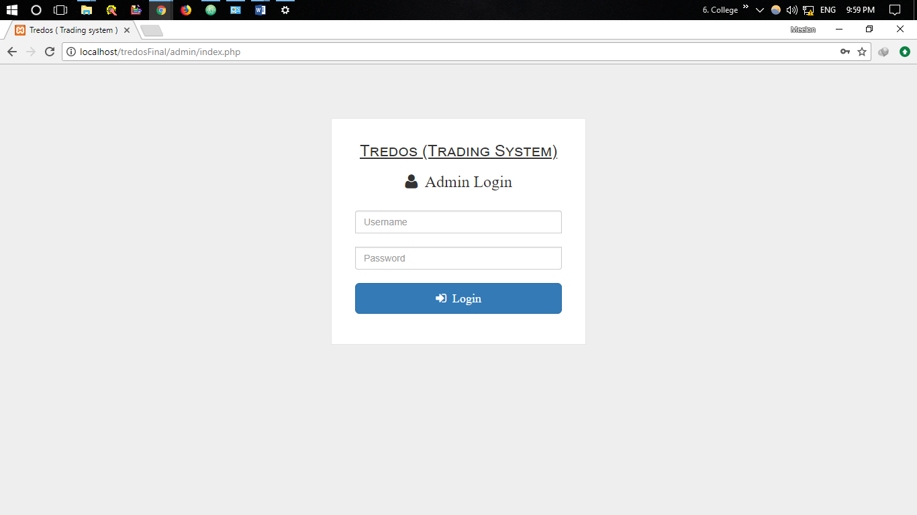

Fig (5). Admin Login Homepage

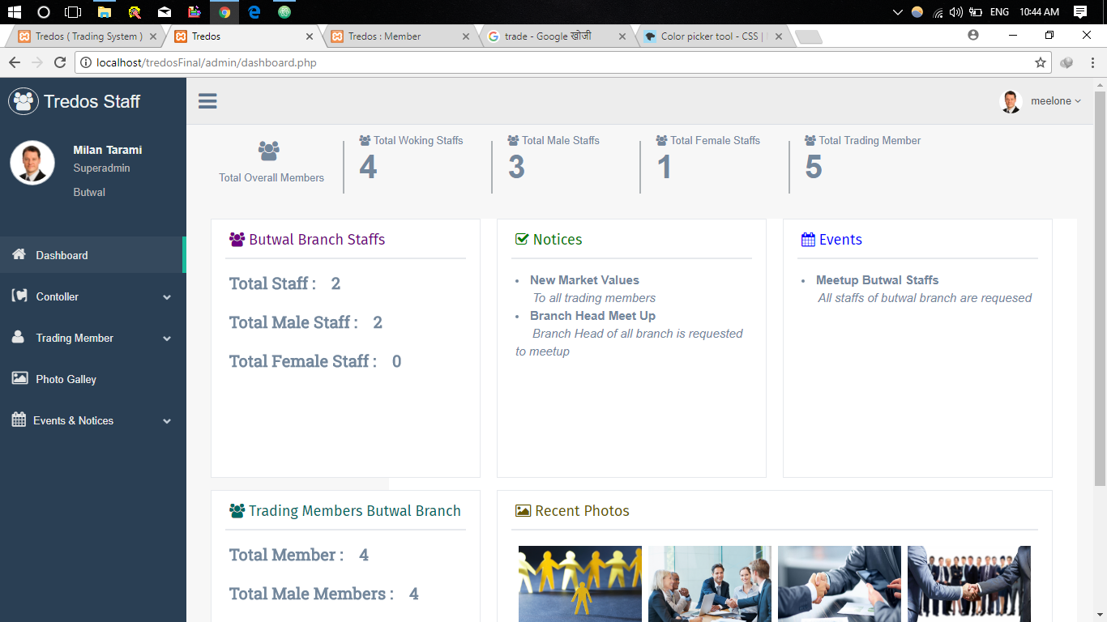

Fig (6). Admin Dashboard Page

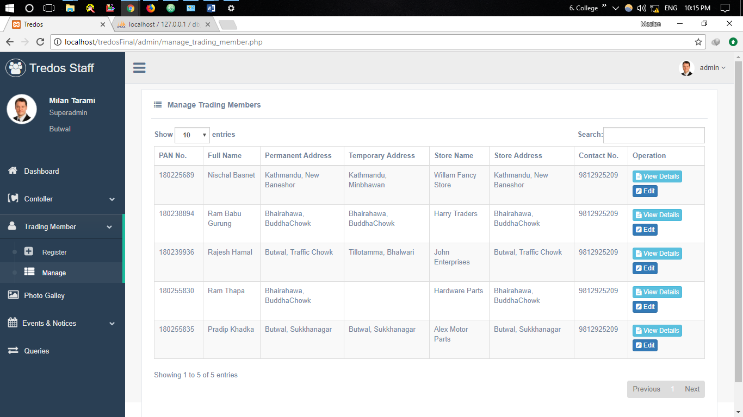

Fig (7).Trading Member Management Page

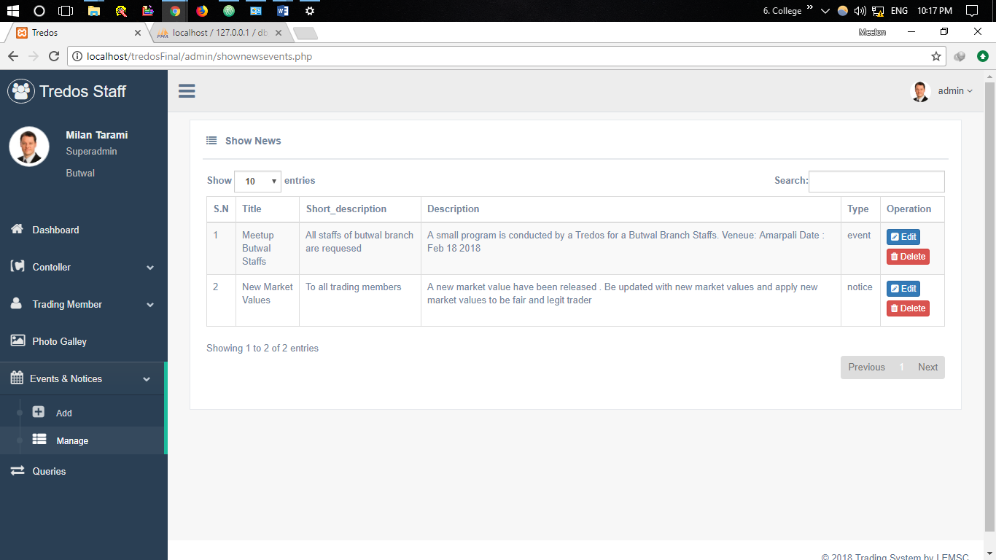

Fig (8). New and Events Management Page

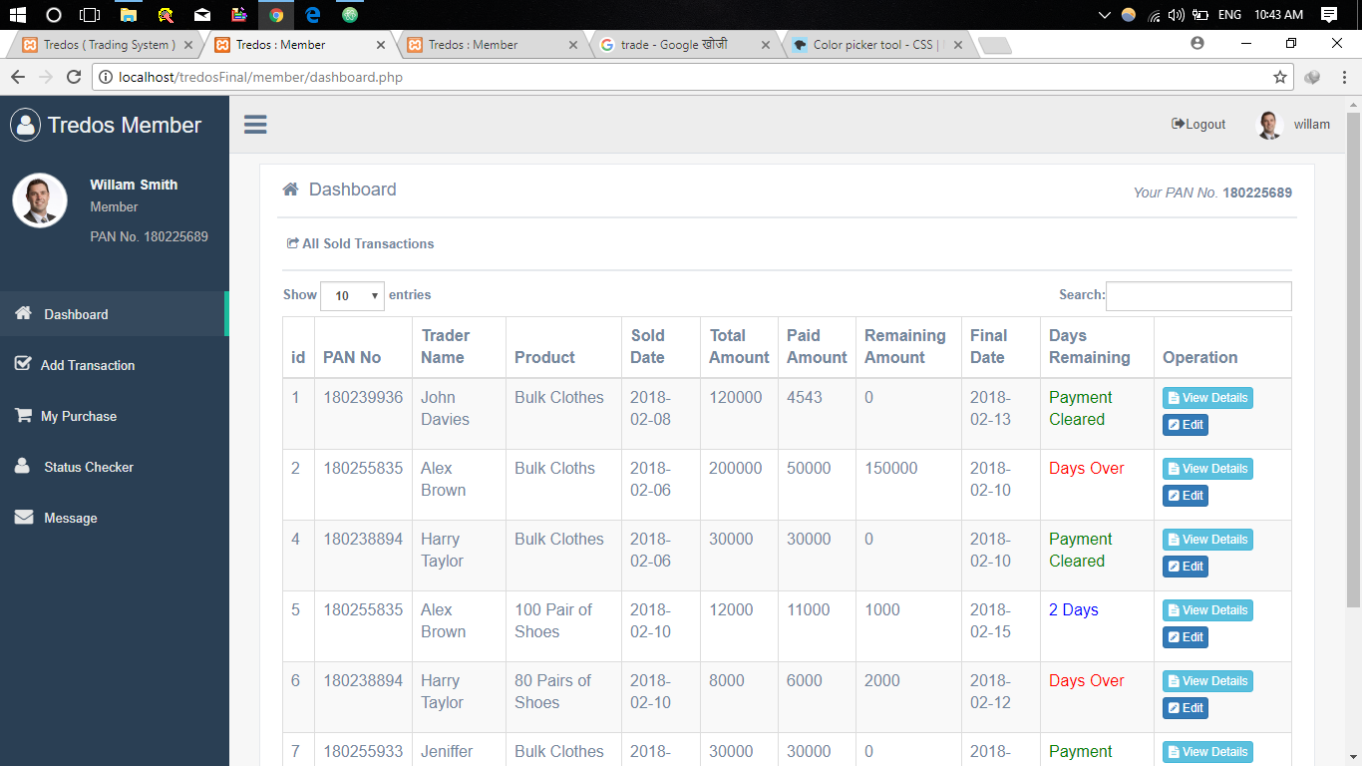

Fig (9). User Dashboard

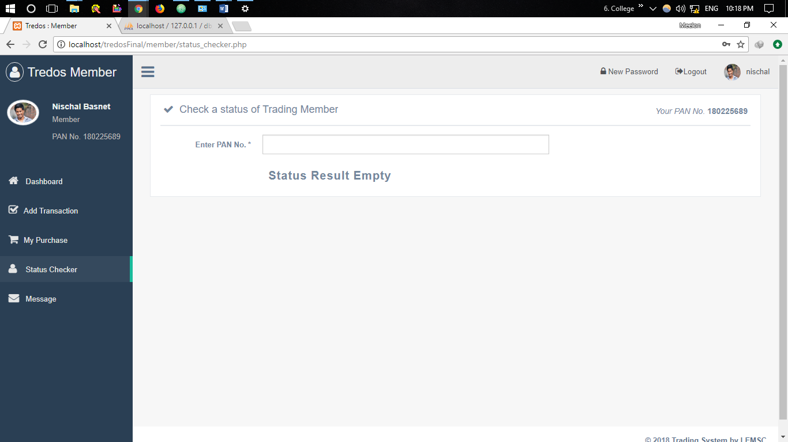

Fig (10). Status Checker

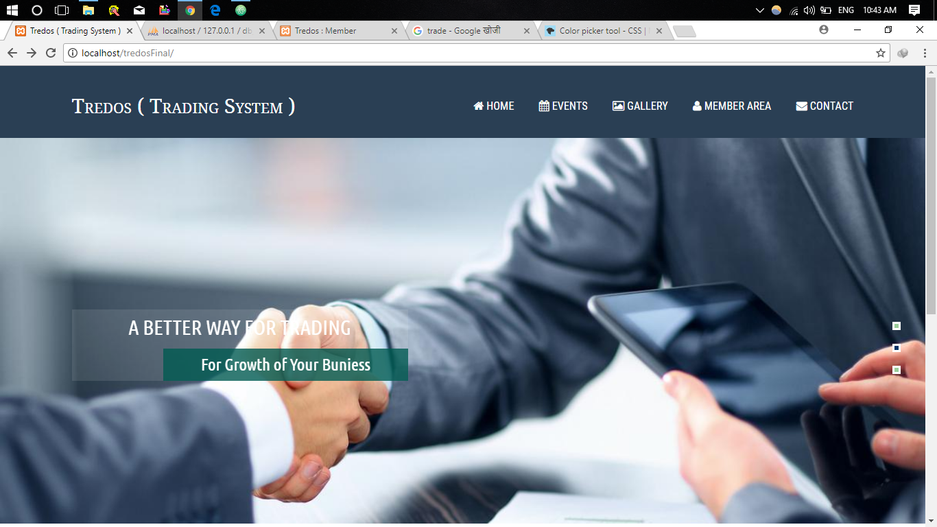 Fig (11). Index Page

**SECTION-E**

**TESTING AND IMPLEMENTAION**

**TESTING**

**INTRODUCTION**

Application testing is a collection of related activities with a single goal to uncover errors in application content function, usability, navigability, performance, capacity and security. To accomplish this, a testing strategy that encompasses both review and executable testing is applied. Software engineers and users all participate in application testing if end user encounter error that shake their faith in the application, they will go elsewhere for the content and function they need, and the application will fail for the reason, we must work to eliminate as many errors over different browsers. The application testing process begins by focusing on user-visible aspects of the application and proceeds to tests that exercise technology and infrastructures. Seven testing steps are performed content testing, interface testing, navigation testing, component testing, performance testing and security testing.

**TEST PROCESS**

We begin the application testing process with test that exercise content and interface functionality that are immediately visible to end users. As testing proceeds, aspects of the design architecture and navigation are exercised.

Finally, the focus shifts to tests that examine technological capabilities that are not always apparent to end user website infrastructure and installation/implementation issues.

Figure below shows the application testing process with the design pyramids for application.

Fig (13). Pyramid Testing

* **Content testing :**

-To uncover syntactic errors

* **Interface Testing :**

When a user interacts with an application, the interaction occurs through one or more interface mechanism. A brief overview of testing considerations for each interface mechanism is presented below:

- Forms:

At a macroscopic level, tests are performed to ensure that:

1. Labels correctly identify fields within the form and that mandatory fields are identified visually for the user.
2. The server receives all information contained within the form and that no data are lost in the transmission between client and server.
3. Appropriate defaults are used when the user does not select from a pull down menu or set of buttons.
4. Scripts perform error checking on data entered work properly and provide meaningful error messages.

* **Navigation testing:**

The first phase of navigation testing actually beings during interface testing. Navigation mechanism are tested to ensure that is performs its intended function. While trying to navigate to different parts of the application, test must be conducted to ensure that each click on the application should lead to correct window.

* **Component level testing:**

Component level testing also called function testing ,function on a set of tests that attempt to uncover errors in application functions .Each application function is a software component (implemented in one of a variety of programming or scripting languages )and can be tested using various techniques. Component level test cases are often driven by forms level input. Once forms data are defined, the user selects a button or other control mechanisms to initiate execution. We must test to make sure the execution goes perfectly without any errors.

**IMPLEMENTATION**

In this phase, the project team actually constructed and hosted the application based on users feedback .The team planned for training and testing in advance our team provides a user manual so that user can easily learn how to manage information with this platform .Following the web application structure we finalized in the design phase ,we made our first prototype which was a rough draft without colors or pictures .The next prototype is to put everything into the web application and make a detailed list of the category. After completing the second prototype we showed the web application to our respected teachers and users and gave a final design to our web application. The following sections will explain the details of our implementation phase.

1. **FIRST PROTOTYPE**

With the content hierarchy, navigation tabs and data we received from the design phase, we started to build our first website prototype with Core PHP. Since this prototype was mainly intended to give the users an overall feeling of navigating through the website, it was a black-and-white application mock-up and did not contain any pictures. The first prototype included main menu, submenus, content we gathered from last phases. It was an initial form of the application for users to provide feedback about whether the way we arranged content was easy to follow.

1. **SECOND PROTOTYPE**

Since the purpose of this prototype was to give the users a chance to evaluate the content and check how well it feeds with the template design, We focused more on editing the data to make it easy for people to read and understand and to make sure it contained enough information to meet users various need for details record keeping.

1. **FINAL PRODUCT**

Based on the feedback from the previous prototypes, we completed certain design aspects and included them in the Final Product. We also clarified the content on our previous prototypes, making it more user-friendly in terms of reading levels. The content was presented at the fourth grade reading level. It was much clearer and more succinct than in the previous prototype.

**SECTION – F**

**LIMITATIONS AND FUTURE ENHANCEMENTS**

**LIMITATION**

No matter how large will an application be, there will be some limitations? The current project carried out with the major limitations are listed below:

* Single product order at a time
* This web app isn’t responsive (only Desktop View)

**CONCLUSION**

Trading system, will be a web app generally designed to detect fraud activities and provide immediate response to the queries of the members. This is generally going to be fraud detector and information provider in the behalf of traders.

**FUTURE ENHANCEMENTS**

* In the later versions, this will application will get updates qrcode scanner features
* Developing Android/iOS App so a user can access our system via smartphone with a single click
* Adding more security for a database and account recovery options

**REFERENCES**

[www.php.com](http://www.php.com)

[www.w3schools.com](http://www.w3schools.com)

[www.stackoverflow.com](http://www.stackoverflow.com)

**Thank you!**